**Project Name:**

Sentiment Analysis for Sexual Assault Call Center

**Statement of Work**

**Student Names:**

Or Moshe - 315876771

Gilad Ben Natan – 313554867

**Supervised by:** Doctor Sharon Yalov Handzel

**Partner names:** Dr. Adi Fux, Shiran Carmeli, Moriya Greenhut

Table of Contents

1. Introduction - 4
   * Project Structure
2. Project Goals – 4-5
   * 2.1 Developing Classification Models
   * 2.2 Developing Sentiment Analysis Models
   * 2.3 User Interface (UI)
3. Project Metrics – 5-6
4. Project Gantt - 6
5. Initial Requirements from the System (High Level) - 7-8
   * 5.1 System Goals
   * 5.2 Stakeholders
   * 5.3 Functional Requirements
6. Non-functional Requirements – 8-9
   * 6.1 Design Requirements
   * 6.2 Performance Requirements
   * 6.3 Maintenance Requirements
   * 6.4 Reliability Requirements
   * 6.5 Privacy Requirements
   * 6.6 Scalability
7. Technological Requirements - 9
   * 7.1 Frontend Technologies
   * 7.2 Backend Technologies
8. Development Tools - 9
9. Compliance and Standards – 9
10. Use Cases – 9-10
    * 10.1 Conversation Input and Analysis
    * 10.2 File Input and Analysis
    * 10.3 Continuous Learning and Model Improvement
11. MVC Design – 10
12. System Flow - 12
13. NLP Model Flow – 11
14. How It Works – 11-15
    * 14.1 Login
    * 14.2 Choose Type of Use
    * 14.3 Enter Text
    * 14.4 Returned Classification and Emotion Detection
    * 14.5 Upload a XL File and Get Classifications for All at Once!
    * 14.6 Return XL for Download
15. The Results – 15-17
16. Literature Review – 17-19
    1. 15.1 Real-Time Sentiment Analysis for Crisis Communication
    2. 15.2 Emotional Analysis of Social Media in Public Health Emergencies
    3. 15.3 Enhancing Support for Domestic Violence Survivors through Sentiment Analysis
    4. 15.4 Predictive Analytics in Legal Outcomes for Violence Cases
    5. 15.5 Sentiment Analysis in Therapeutic Settings
17. Bibliography – 19-20

# Introduction

In our world today, the disturbing prevalence of violence against women and girls demands our attention and a proactive response. This project uses Natural Language Processing (NLP) to address this critical issue by creating a tool to understand and identify the specific help women need when they share their traumatic experiences.

Our goal is to bridge the gap between survivors and the support they seek. By leveraging NLP, we aim to deeply analyze narratives and provide targeted, immediate assistance. We will use advanced NLP models to develop a system that goes beyond basic sentiment analysis, identifying specific needs such as legal aid, counseling, or emergency support.

**Project Structure**

The project will be divided into three main parts: algorithm development, client-side application, and server-side application.

**Algorithm Development**

We will develop an algorithm using existing neural networks and computer vision libraries. This algorithm will process text to identify the needs of women accurately, training it on various datasets to ensure effectiveness.

**Client-Side Application and User Experience**

We will develop the user interface of the system, focusing on design and user experience to ensure the application is functional and easy to use.

**Server-Side Application**

This part will manage backend operations, ensuring efficient and secure data processing, storage, and retrieval. It will integrate the NLP algorithm with the client-side application for real-time responses.

This concise overview sets the stage for our project, highlighting the potential of technology to address a critical issue. As we progress, we will explore the technical details, ethical considerations, and real-world impacts of our NLP-based solution for recognizing and responding to violence against women and girls.

# 2**.** Project Goals:

Our project is dedicated to enhancing support services for survivors of violence against women and girls through the application of Natural Language Processing (NLP). By developing an NLP model trained on a dataset encompassing legal, counseling, and emergency contexts, we strive to quickly and precisely categorize new text conversations. A key aspect of this project is creating an intuitive interface that simplifies the analysis workflow. This initiative focuses on providing timely and relevant assistance to survivors, setting a solid foundation for a detailed examination of each phase of the project.

2.1. **Developing Classification Models**

* Building conversation classification models based on both English and Hebrew. For each language we will create a few models, and, in the end, we will choose the best model by analysis the measure of success.

2.2. **Developing sentiment analysis Models**

* Creating models to detect emotions from conversations, supporting both English and Hebrew. For each language we will create a few models, and, in the end, we will choose the best model by analysis the measure of success.

2.3**. User Interface (UI):**

* Design and build a user-friendly UI allowing easy input of new text conversations. This interface will be integral in facilitating the immediate analysis of conversations.

In addition, the UI include integration with the WhatsApp and the system will send notifications to the agent according to the sentiment of the conversation.

# 3. Project Metrics

To effectively evaluate our project, we have outlined specific, quantifiable objectives as follows:

We will use compute metrics to analysis the result of the classification models by:

* **Accuracy**: The proportion of correctly predicted instances out of the total instances.
* **Precision**: The proportion of true positive predictions out of all positive predictions.
* **Recall**: The proportion of true positive predictions out of all actual positives.
* **F1** **Score**: The harmonic mean of precision and recall, providing a balance between the two.

For the sentiment analysis models we will use in loss function:

a loss function quantifies the difference between the predicted sentiment of a text (not relevant, information, emotional, high risk) and its actual sentiment. It guides the training of a model by measuring the error in predictions, helping the model adjust to minimize this error over time. Common loss functions used include cross-entropy loss for categorical sentiment labels.

For both models we will try to:

* Reach a minimum accuracy of 80% in accurately determining calls as urgent or non-urgent, confirming the model's dependable recognition of the sentiment and urgency in conversations.
* Achieve precision and recall rates of at least 75% in identifying various support needs (not relevant, information, emotional, high risk), to reduce misclassification and guarantee that survivors obtain the correct support.

# 4. Project Gantt

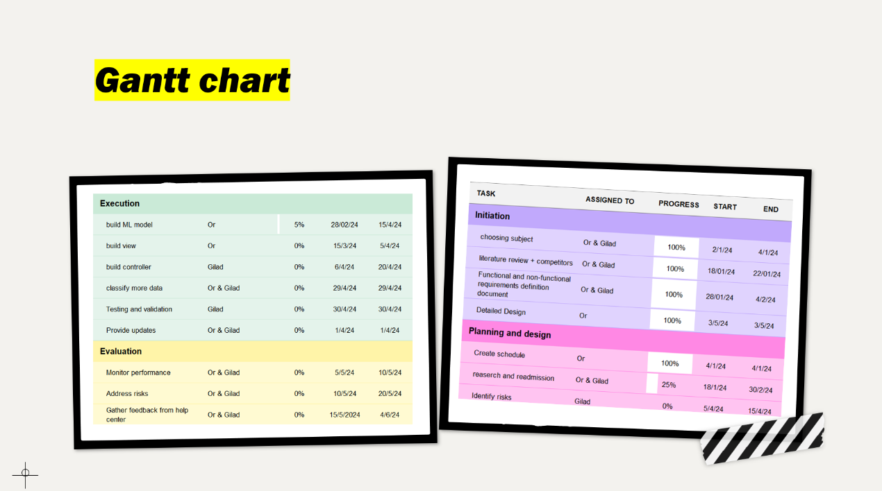

# 5. Initial requirements from the system (High Level)

5.1. System goals

As outlined in previous sections, the primary objective of this project is to develop a Natural Language Processing (NLP) model capable of analyzing calls from sexual harassment support centers. This model will classify calls as (not relevant, information, emotional, high risk) based on sentiment analysis. In addition, the system provide a detection of the conversations such as:

despair, loneliness, emotional overflow, self blame, anxiety, distrust / confusion, new assault / new exposure, level of suicide/ level of risk, obligation to report according law, 'support for support circuls

5.2. Stakeholders

Stakeholders in this project are:

* Support center staff.
* System administrator.
* Legal and counseling professionals.
* Developers.

5.3. Functional requirements

5.3.1. Requirements from the NLP Model

* The NLP model should precisely categorize the urgency of calls through sentiment analysis, maintaining strong dependability in differentiating between not relevant / information / emotional / high risk conversations.
* The model will consistently enhance its accuracy by learning from fresh data gathered from text conversations.

5.3.2. System Requirements

* Guarantee uninterrupted communication between the server that hosts the NLP model and the user interface, enabling instant analysis and categorization of text conversations.
* Conduct all training, text analysis, and classification tasks of the NLP model on the server to reduce the computational burden on the user's device.

5.3.3. Requirements from the User Interface (UI)

* The UI will feature a straightforward and user-friendly dashboard that allows users to enter new text conversations and see the results of the analysis.
* Show comprehensive results of the sentiment analysis, including the urgency classification for each conversation.
* File Upload: Provide functionality for support representatives to upload files related to survivor cases.
* Notifications: Provide real-time updates on survivor interactions.

# 6. Non-functional Requirements

6.1. Design Requirements

* The interface should be user-friendly, allowing users with no technical background to navigate and utilize the system effectively from their first interaction.
* Adopt a minimalist design approach to ensure clarity and prevent user overwhelm, facilitating a straightforward analysis process.

6.2. Performance Requirements

* Ensure system efficiency with large datasets for timely support.
* Maintain high accuracy in trauma recognition.

6.3. Maintenance Requirements

* Establish mechanisms for regular updates and system maintenance.
* Ensure adaptability to evolving needs and technologies.

6.4. Reliability Requirements

* Ensure system stability and reliability, maintaining high availability for users to access and use the application as needed.

6.5. Privacy Requirements

* Adhere to privacy regulations to protect survivor confidentiality.
* Implement security measures to prevent unauthorized access.

6.6. Scalbility

* While initially designed for lower traffic, the system architecture should allow for future expansion, such as adding more server resources or optimizing the database for faster queries as user demand increases.

# 7. Technological Requirements

7.1. Frontend Technologies

* Use HTML, CSS, and JavaScript to ensure a modern and accessible web application.

7.2. Backend Technologies

* Python for ML models
* Server – flask
* Web service – python

# 8. Development Tools

* Git for version control .
* PyCharm google colab for model development and backend.
* Visual Studio Code for UI development.

# 9. Compliance and Standards

Adhere to RESTful API standards and use JSON for data interchange between the front and back end.

# 10. Use Cases

10.1. Use Case 1: Conversation Input and Analysis

* Actors: Support center staff
* Basic Flow:
* The user choose the language of the input text.
* The user inputs a new text conversation.
* The system categorizes the conversation as not relevant / information / emotional / high risk and display the results to the user.
* The system analysis the emotion detection of the conversation and display the results to the user.

10.2. Use Case 2: File Input and Analysis

* Actors: Support center staff
* Basic Flow:
* The user choose the language of the input text.
* The user upload a file of conversations without classifications.
* The system categorizes each of the conversations inside the file as not relevant / information / emotional / high risk and display the results to the user.
* The system analysis the emotion detection of the conversation and display the results inside the file.

10.3. Use Case 3: Continuous Learning and Model Improvement

* Actors: developers
* Preconditions: New data from analysed conversations is available for training.
* Basic Flow:
* Developers collect and prepare new training data from recent conversations.
* The NLP model is retrained with the updated dataset to improve accuracy.
* The updated model is deployed, enhancing future sentiment analysis and urgency detection.
* Postconditions: Based on the latest conversational data, the system's ability to accurately identify urgent messages is improved

# 11. MVC Design

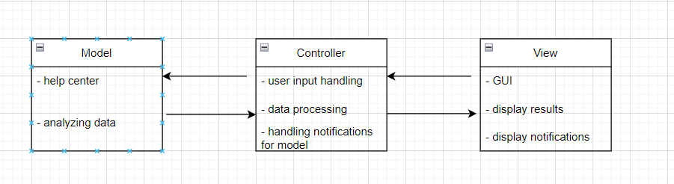

# 12. System Flow

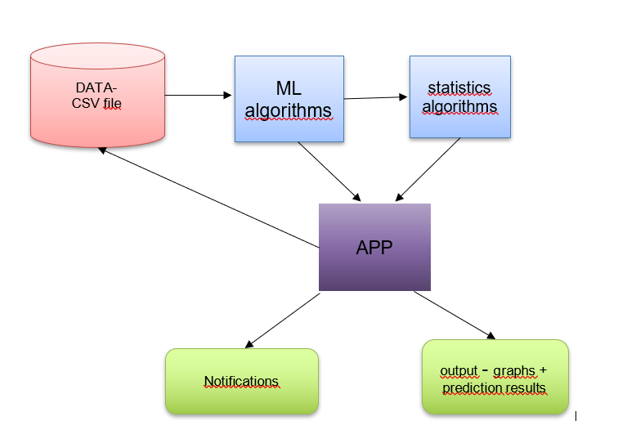

# 13. NLP Flow



# 14. How It Works

14.1. login

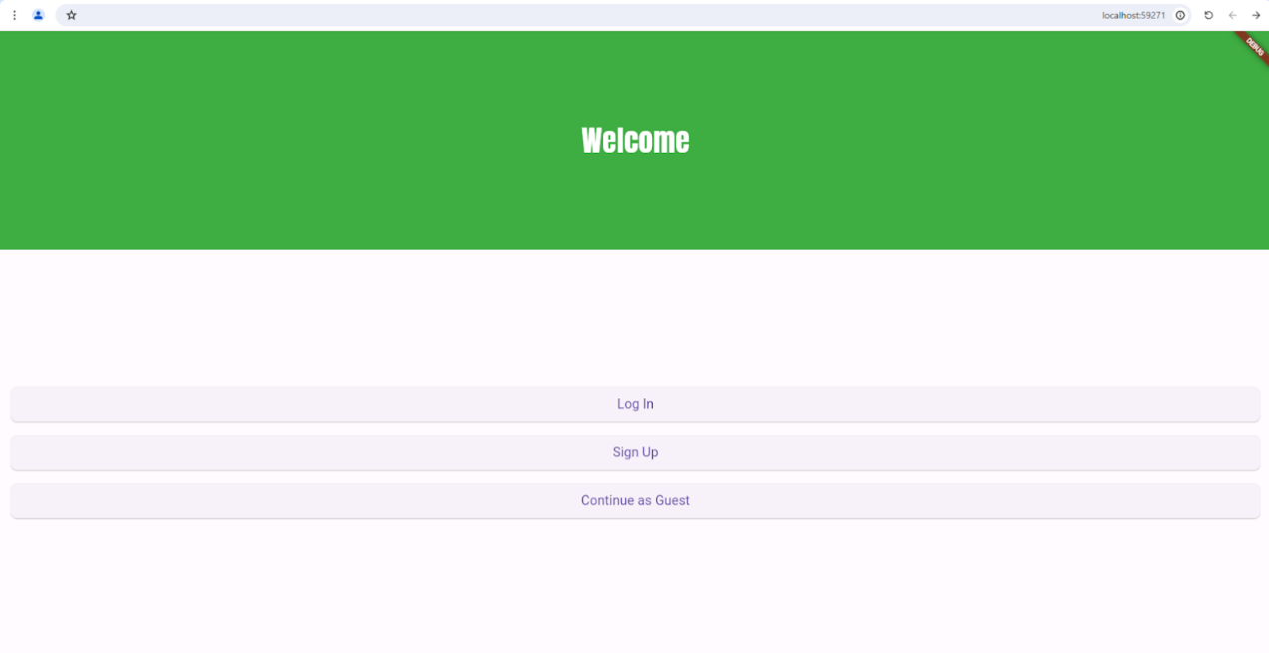

14.2. Choose type of use

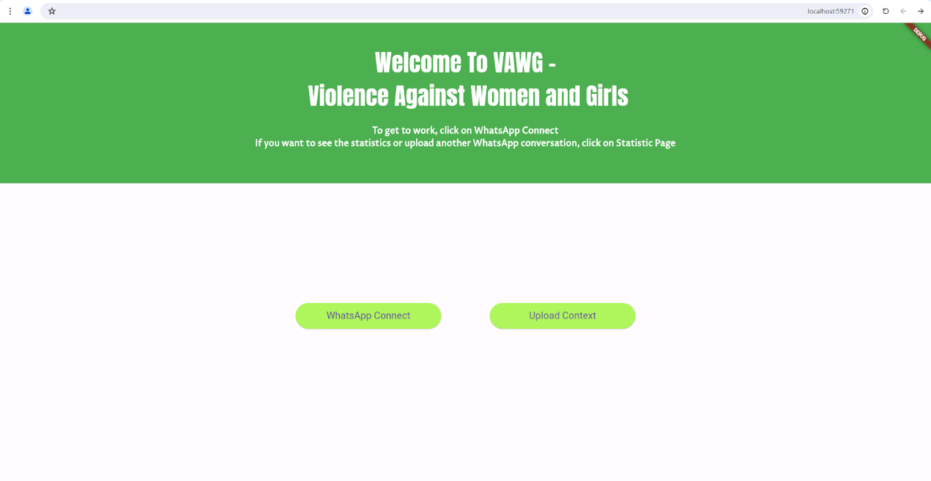

14.3. Enter text

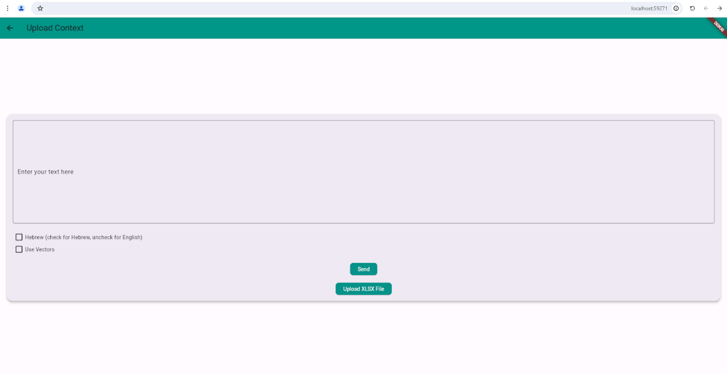

14.4. Returned classification and emotion detection

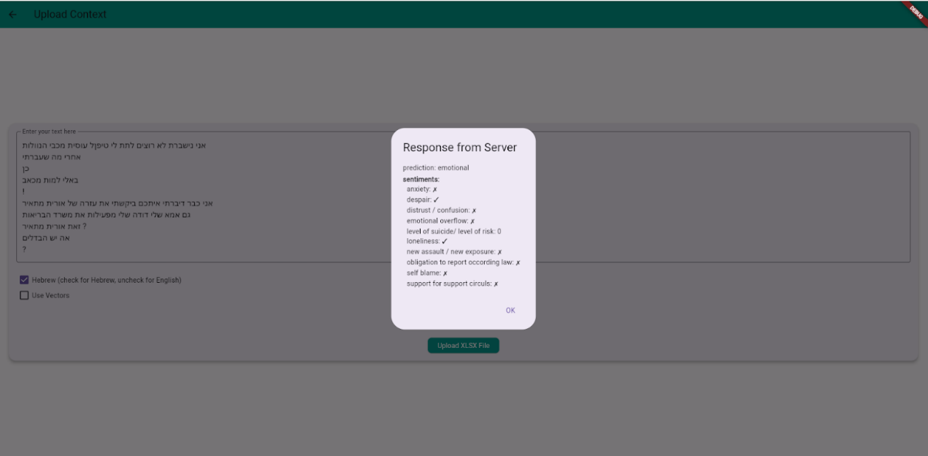

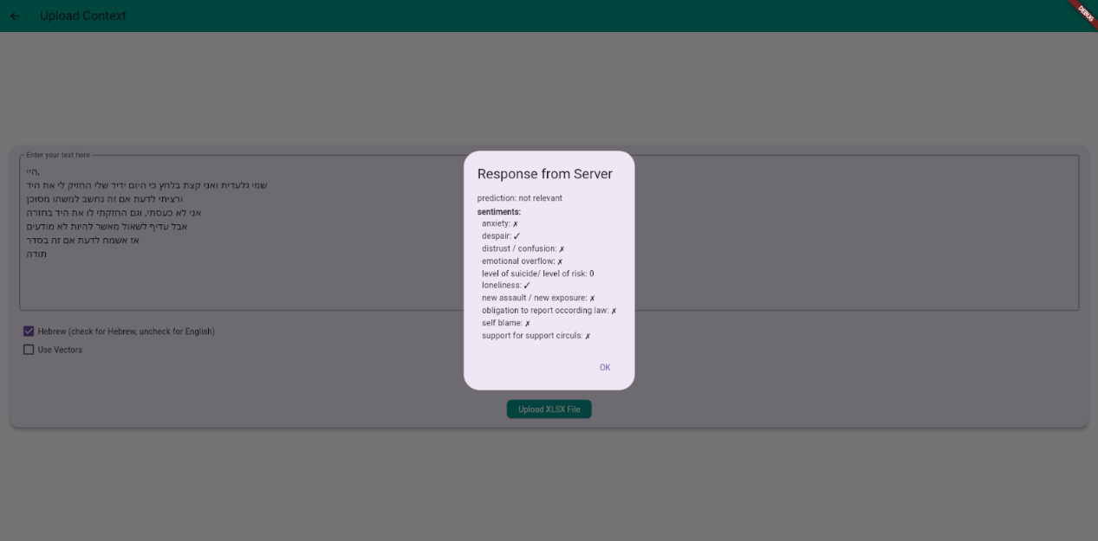

14.5. Upload a XL file and get classifications for all at once!

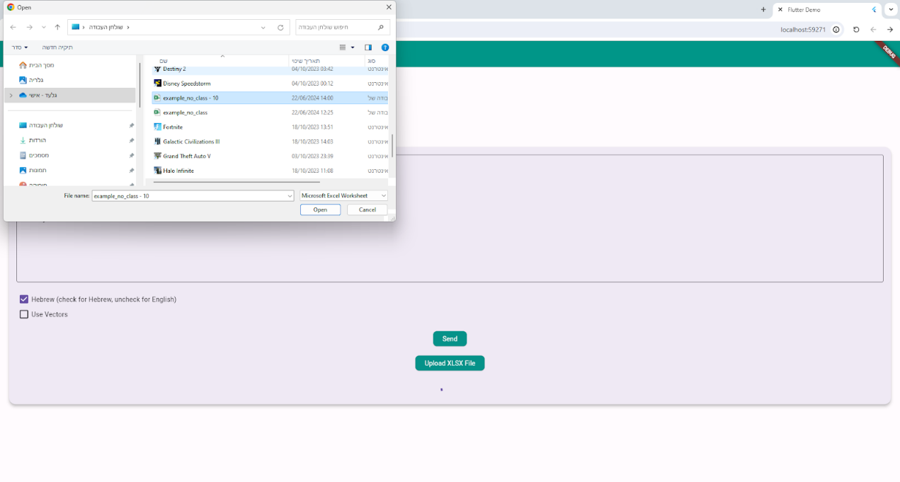

14.6. Then it return: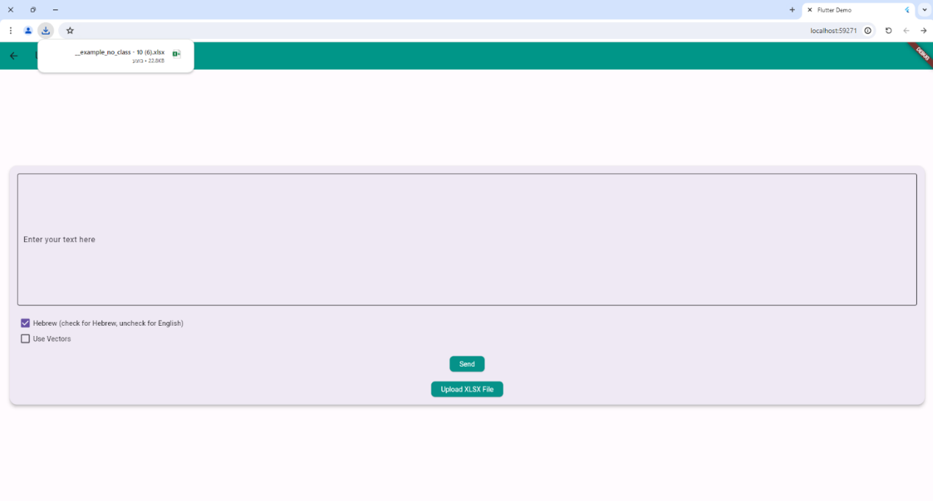14.7. Returned you a XL for a download

The XL with classifications

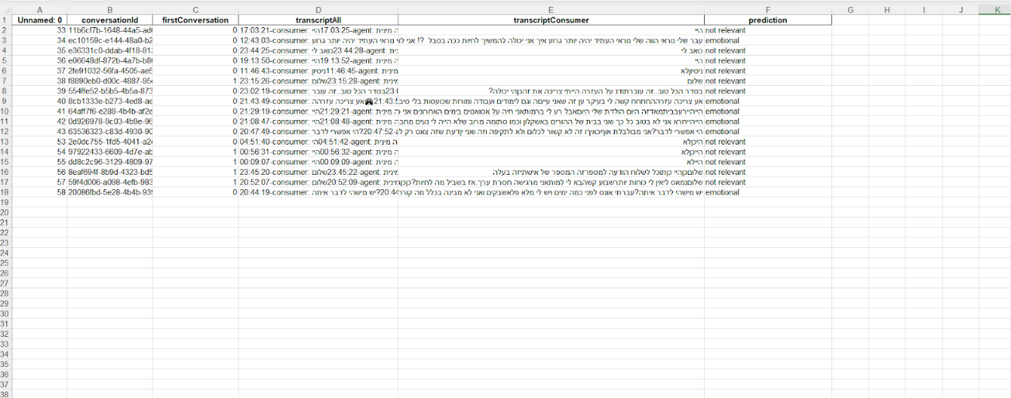

# The Results:

Classification model “bert” English:

Training:

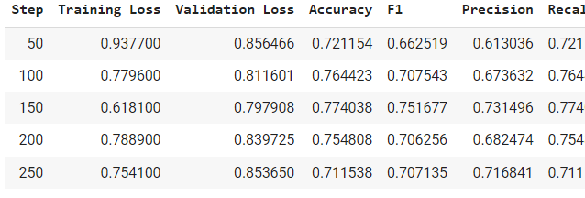

Classification model “bert” Hebrew:

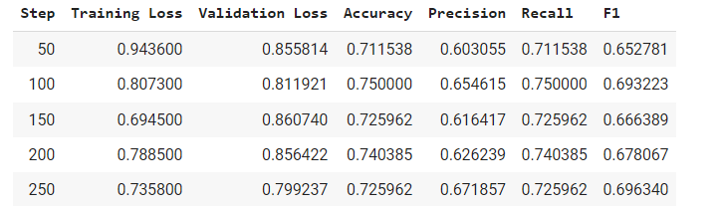

Sentiments model “Roberta” English:

Training:

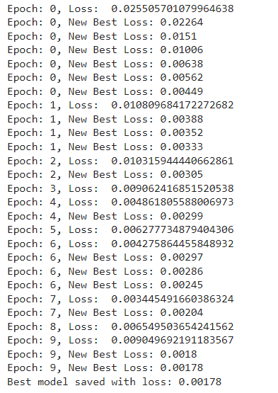

Validation:



Sentiments model “bert” Hebrew:

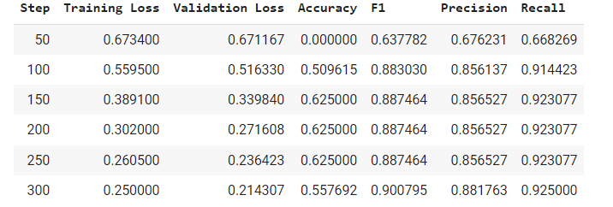

# 16. Literature Review

Background In the fields of natural language processing (NLP) and machine learning, sentiment analysis has emerged as a potent tool for deciphering human emotions from text. This literature review delves into the application of sentiment analysis to text conversations from sexual assault support centers. Given that survivors increasingly use digital platforms for assistance and to share their stories, analyzing the sentiments in these conversations is critical. This review seeks to examine the existing research methodologies, challenges, and ethical issues, illuminating how sentiment analysis can bolster support systems for survivors of sexual assault.

Sentiment Analysis Sentiment analysis, or opinion mining, is an NLP technique aimed at computationally assessing text to determine the expressed sentiments or emotional tones. It primarily involves:

* Text Input: Initiating sentiment analysis with text input that ranges from brief sentences to extensive documents.
* Text Preprocessing: Implementing preprocessing steps such as removing special characters, tokenization, and stemming or lemmatization to refine the data before sentiment evaluation.
* Sentiment Classification: At the core, it classifies text into categories like positive, negative, or neutral based on the sentiment conveyed.

Selected Research Papers

* 1. Real-Time Sentiment Analysis for Crisis Communication (Chen & Lazer, 2021)

**Overview**: Investigates the application of real-time sentiment analysis to improve crisis communication strategies, focusing on emergency response scenarios.

**Methodology**: Employs advanced NLP techniques to analyze live communication data, adapting to the dynamic nature of crisis situations.

**Findings**: Demonstrates the effectiveness of sentiment analysis in providing actionable insights during emergencies, enhancing response efforts.

**Further Research:** Recommends development of more adaptive models that can handle rapidly changing data contexts in crisis situations.

* 1. Emotional Analysis of Social Media in Public Health Emergencies (Kumar & Smith, 2022)
* **Overview**: Analyzes the emotional content of social media posts during public health emergencies to better understand public sentiment and misinformation.
* **Methodology**: Uses a combination of sentiment analysis and emotional detection to study public reactions and the spread of information.
* **Findings**: Highlights how sentiment analysis can identify shifts in public mood and misinformation trends, aiding in targeted public health messaging.
* **Further** Research: Suggests integration with automated misinformation detection systems to improve public health communication.
  1. Enhancing Support for Domestic Violence Survivors through Sentiment Analysis (Garcia et al., 2024)
* **Overview**: Explores the use of sentiment analysis in providing tailored support to survivors of domestic violence by analyzing communication patterns.
* **Methodology**: Applies machine learning models to identify sentiment and emotional cues in text messages between survivors and support services.
* **Findings**: Shows potential in using sentiment analysis to customize support strategies and intervention methods based on individual emotional states.
* **Further Research:** Calls for larger, more diverse datasets to train more accurate and sensitive models.
  1. Predictive Analytics in Legal Outcomes for Violence Cases (Lee & Nguyen, 2023)
* **Overview**: Examines how predictive analytics and sentiment analysis can forecast legal outcomes in cases of violence, aiming to better prepare legal advocates and survivors.
* **Methodology**: Combines sentiment analysis with predictive modeling to assess case narratives and predict trial outcomes.
* **Findings**: Finds that sentiment analysis can significantly influence the prediction accuracy of legal outcomes, offering a valuable tool for legal strategy.
* **Further Research**: Proposes refining models to incorporate a wider range of emotional and psychological factors.
  1. Sentiment Analysis in Therapeutic Settings (Ortiz & Fitzgerald, 2024)
* **Overview**: Studies the application of sentiment analysis in therapeutic settings to gauge patient sentiment and therapy effectiveness over time.
* **Methodology**: Implements NLP techniques to analyze patient language during therapy sessions, aiming to correlate sentiment shifts with therapy outcomes.
* **Findings**: Provides insights into how sentiment analysis can be a proxy for emotional changes and therapy progress.
* **Further Research**: Suggests exploring multi-modal data integration, including vocal tone and body language, to enhance sentiment analysis.

# Bibliography

1. Chen, H., & Lazer, D. (2021). Real-Time Sentiment Analysis for Crisis Communication. Journal of Communication Technology and Crisis Response, 5(2), 117-134.
2. Kumar, A., & Smith, B. (2022). Emotional Analysis of Social Media in Public Health Emergencies. Public Health Informatics Journal, 9(1), 89-105.
3. Garcia, M., Thompson, R., Patel, K., & Johnson, S. (2024). Enhancing Support for Domestic Violence Survivors through Sentiment Analysis. International Journal of Social Work and Human Services Practice, 12(3), 202-218.
4. Lee, J., & Nguyen, T. (2023). Predictive Analytics in Legal Outcomes for Violence Cases. Journal of Legal Studies and Forensic Science, 14(4), 250-266.
5. Ortiz, R., & Fitzgerald, D. (2024). Sentiment Analysis in Therapeutic Settings. Journal of Behavioral Therapy and Technology, 6(2), 134-150.